Coordination Committee Teleconference Notes
Date: 05/06/19
Time: 3:00-4:00pm
In Attendance: Beth Neary (SFDPH), Christina Nip (SFDPH), Kim Levine (SFUSD), Paul Rohde (AFL Enterprises), Prasanthi Patel (SFDPH), Tomoko Isogai (SFUSD), Susan Fisher-Owens (UCSF)
AGENDA ITEMS | NOTES | ACTION ITEMS
Pilot 1 Updates | Paul:  - Faculty: Our expert faculty: Dr. Irene Hilton is the Chair of the Collaborative, Dr. Lyra Ng (pediatrician), Dr. An Nguyen (dentist at an FQHC in Colorado with extensive QI expertise), Dr. Ramona English (dentist at Petaluma Health Center with dental QI experience), Dr. Ray Stewart (UCSF). Trevor Ahrendt is teaching motivational interviewing and self-management goal setting. Dr. Irene Hilton is the Chair of the Collaborative  - Clinic Recruitment: recruited 5 clinic teams to participate in the first round (we are planning 3 cohorts). We learned that the UOP Virtual Dental Home clinic will cease operations in June 2019  - We conducted site visits to the Bayview clinic and the virtual dental home to teach small scale testing. The clinics are all reporting very small #s of kids 0-5 with Medi-Cal dental. Range is from 0 to 17 children served in a month. Part of their improvement work includes strategies to increase their pediatric population, as well as create a child-friendly, patient-centered environment. See a sample Dashboard for one team – this is exciting progress! They can track and report data, and use it to guide improvement  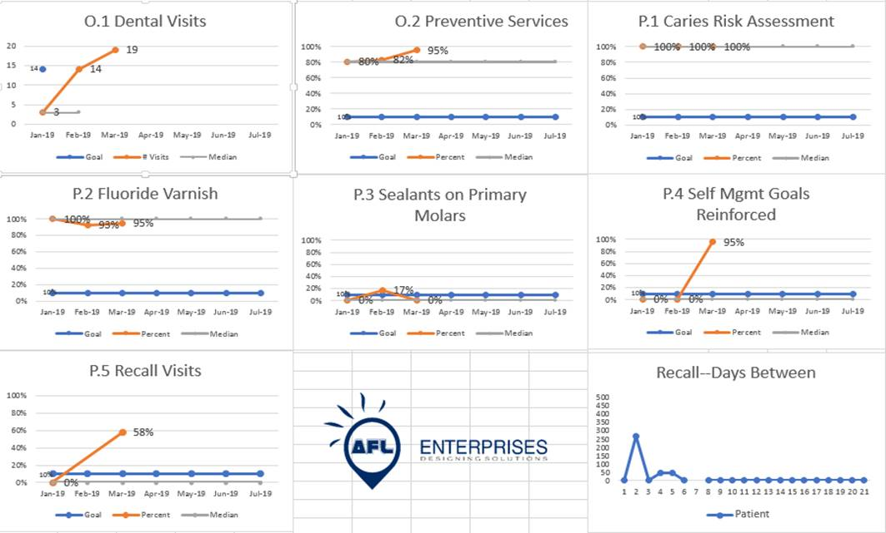  - Learning Sessions: Learning Session 2 took place last week (4/24 & 4/25). All 5 teams participated. Practices learned about strategies to increase their pediatric populations, and heard from Pilot 2 – Outreach, Becky Sung, Christina and Rose presented. Teams were very interested in this work, and being a referral for families. The agenda was designed to help practices think about once you get the patients in the door, how to develop continuity to create a dental home. Lyra Ng challenged us “you might get them in the door, but you won’t keep them if you don’t build a trusting relationship with families.” Trevor Ahrendt taught motivational interviewing and active listening. Learning Session 3 is scheduled for 6/27 & 6/28.  - Recruitment for Cohort 2: We need to recruit 15 practices. So far we have 2 applicants: Ocean Breeze Dental and Silver Avenue. We have sub-contracts with San Francisco Dental Society and Community Clinic Consortium to serve as recruitment partners.  - Please help/What we need from the Coordinating Committee. Applications are available at: https://sfdti.weebly.com/pilot-1-dental-access-collaborative1.html. We need to recruit 15 practices, so if you know of anyone who is a potential candidate (dental practice in San Francisco serving, or willing to serve, children 0-5 enrolled in Medi-Cal), please send them to us at sfdtiaccesscollaborative@afl-enterprises.com or call us at (805) 491-5741. | All to help get the word out for recruitment application for next Dental Access Collaborative (application open 03/18, deadline 5/31)  Christina to include link, flyer and info for Pilot 1 Recruitment in follow-up email
Pilot 2 Updates | Christina:  - Care coordination #s for April 2019  - 176 clients referred (YTD 18%)  - 172 clients contacted (YTD 21%)  - 123 clients appointed (YTD 18%)  - 101 clients attended visit (YTD 17%)  - Still working to bring onboard a Spanish speaking HW to join the DTI care coordination team  - Working with NICOS Chinese Health Coalition & Dr. Trevor Ahrendt to create an online recording of MI introductory training as a refresher resource, and for new HWs and School Nurses new to dental care coordination work on DTI  Kim:  - Upcoming “Community Oral Health: What Every Health Worker & Advocate Should Know” training on May 8th for HWs and School Nurses at SFUSD  - Share numbers on care coordination as of 03/31/19 with Christina:  (01/23/19-03/31/19)  - Students referred: 1978  - Calls made: 916  - Appointments made: 179  - Appointments attended: 76 (confirmation numbers should improve over next few months)
Pilot 3 Updates | Prasanthi:  - Taskforces still discussing how they would like to move forward with design thinking work  - Taskforces working on media campaign through Prop 56. D10 taskforce has some media campaign materials (posters, flyers) ready for sharing. Mission taskforce has come up with some potential messages, but no materials ready for sharing yet  Susan:  - Working with students to do messaging specific to grandparents population in Chinatown  - Would like to learn/be involved in the message development process when it takes place  Christina:  - Training happening on May 8th on focus group findings from 2018 will be presented by the three taskforces  - Taskforces have agreed and are in support of holding a focus group for dental providers  - Next step, hoping to condense dental provider related focus group findings for further discussion and development of focus group questions/guide | Christina to condense dental provider related findings for the group to come together to develop focus group guide/questions
Pilot 4 Updates | Susan:  - Shared work on integration and gave examples of challenges and means of dealing with challenges on oral health integration in the primary care setting with the DHCS state reps.  Christina:  - Met with John Huang-Pediatric lead at UCSF China Basin, Lakeshore, & Laurel Village, and Dr. O’Brien at Mt Zion on April 8th. We have been receiving a few referrals from UCSF  - Had recommendations for the paper referral form to include a feedback loop for providers to learn outcome of care coordination
Pilot 5 Updates | Christina:  - SEHC started Pilot 5 participation in 2019, rolling out warm handoff. (05/02 data pull @ 29% Dual User Rate. 10% RI Goal is 34%, and 20% RI Goal is 41%)  - SAFHC decided not to expand warm handoff. Concerns with anticipated EPIC transition. Clinic capacity, clinic access in question (05/02 data pull @ 24% dual user rate. 10% RI goal is 56% and 20% RI goal is 60.5%)  - NEMS submitted contract documents. First pilot meeting set for 05/17 (Fri)  - MNHC worked with Anastassia on their dual user reporting data template to be pulled monthly. Had first Pilot 5 meeting 04/18. Primary Care pediatric team have begun referring patients 0-5 to South Van Ness Clinic.
Data & UCSF Monitoring and Reporting Updates | Christina:  - Ben and team worked on Pilot 3 Focus Group training evaluation form.  - Data team discussed Care Coordination data re-run and data items we may be requesting from SFUSD on annual basis. | Christina will connect with Kim offline to talk about data request from SFUSD and setting up technical assistance from Anastassia
Fiscal Updates | Beth:  - We submitted a consolidated Q1-Q4 2018 report two weeks ago and the 2019 Quarter 1 report will be submitted shortly, draft is prepared  - DHCS came for a site visit on 4/29 (Emily Watts and Donnie Boyett) and it was a wonderful visit and each of our pilots represented very well and everyone’s help is greatly appreciated  - DHCS has not yet sent the amended DPH-DHCS contract to incorporate the supplemental 2019 and 2020 funding. The expanded funding is budgeted on the DPH side, and we will begin modifying the contracts with AFL Enterprises and SFUSD this week (funding notice to SFUSD last week), and UCSF in the next month  - Our 2018 Q4 invoice is under review with DHCS. We will submit our 2019 budget modification to carryforward unused 2018 funds into 2019 on 5/13  - NEMS Contract – NEMS contract is working through the 2-month certification process
Cavity Free SF | Prasanthi:  - Strategic planning process for 2020-2030 underway, and had a kick-off meeting, looked at ideal journey map for children’s oral health, and reflected on past successes and performance for work teams. Will be going back to each work team for deeper reflection  - Will be looking at incorporating DTI, and seeing what pieces to include in the strategic plan  - Working on evaluation plan for Prop 56 due end of June  - Margaret is transitioning into retirement, Prasanthi will be the main contact if there are questions related to CavityFree SF
Transition Update | Christina:  - Maternity leave starts May 27th. Official last day is May 24th.  - Looking to streamline and aligning meetings-Pilot 4 meeting folded into CavityFree SF integration meetings  - Pilot 3 discussion will also be folded into the Promotion team meeting  - Link to Online Notes: Suggestion to update notes of meeting live like in CFSF meetings https://docs.google.com/document/d/1_saeuG0b0wy4cjDQPCjrMlEs3rZvHmpnhOfOWzo1XdY/edit?usp=sharing  - Link to Pilot Contact List:  - https://docs.google.com/document/d/1MPAFL3TPKSmfQcCL0wd5MA5fo55nGoYMNG2QK5vokuU/edit?usp=sharing  - There is a DTI SharePoint for internal staff and DTI partners to access project materials, and a public DTI website to access resources. Christina will send out link, for everyone to test out the link | CC to review contact list to check for accuracy and to see if anyone needs to be added to the list  Christina will confirm that DTI SharePoint site is available to the Coordination Committee team. CC to check they can access SharePoint.  Christina will send out link to public DTI website for resources
Next Meeting | Next meeting Monday, July 1, 2019, 3-4pm, via teleconference. (June 3rd meeting cancelled)

